INTER NATIONAL INSTITUE OF FASHION DESIGN
KONDHWA, PUNE
http://www.inifdkondhwa.com
http://www.fashioninstitutepune.com

INIFD, the world’s largest design Institute was launched by famous designer ‘Ritu Beri’ .In 1995; this is now backed by world’s top design institute, IMB Milan (Italy). INIFD has been awarded ‘The Most Promising Company’ of India awarded by DLIQ, Australia.

INIFD KONDHWA Salient features:
- Wi-Fi campus & hostel.
- Hostel within INIFD Kondhwa Campus.
- Annual Fashion shows covered by the Media.
- Industrial Visits/ Tours
- Guest lectures by the leading Professionals.
- Workshops by the leading Bollywood Fashion Designers.
- Fashion Photo shoots.
- Creative Workshops.
- Kids Fashion Shows.

INIFD campus in Kondhwa provides students all the possible facilities for their learning and career development. Apart from this, the Institute boasts of expert faculty which helps the students to shape their careers and pass on the best of knowledge that empowers them to compete successfully on a global platform. Students here get a chance to participate in various fashion events/contests and also get to participate in the Lakmé Fashion Week (Official Knowledge Partners) as Gen Next designers to showcase their talent.

Programs offered in Fashion & Interior Design
1 Year Foundation Program.
2 Years Advance Professional Program.
3 Years Specialization Program.
2 Years Super Specialization Program
We are proud to be associated with:
International Partner: London School of Trends
London School of Trends is a premier Fashion School with rich experience in the Fashion & Design Industry. LST believes in nurturing the talent & creativity of its students. The teaching methodology maximizes student- teacher interaction through project based assignments & practical hands on training. LST in collaboration with INIFD ensure that students get the best design training that a city like London has to offer at an affordable price.

INIFD Academy of Interiors
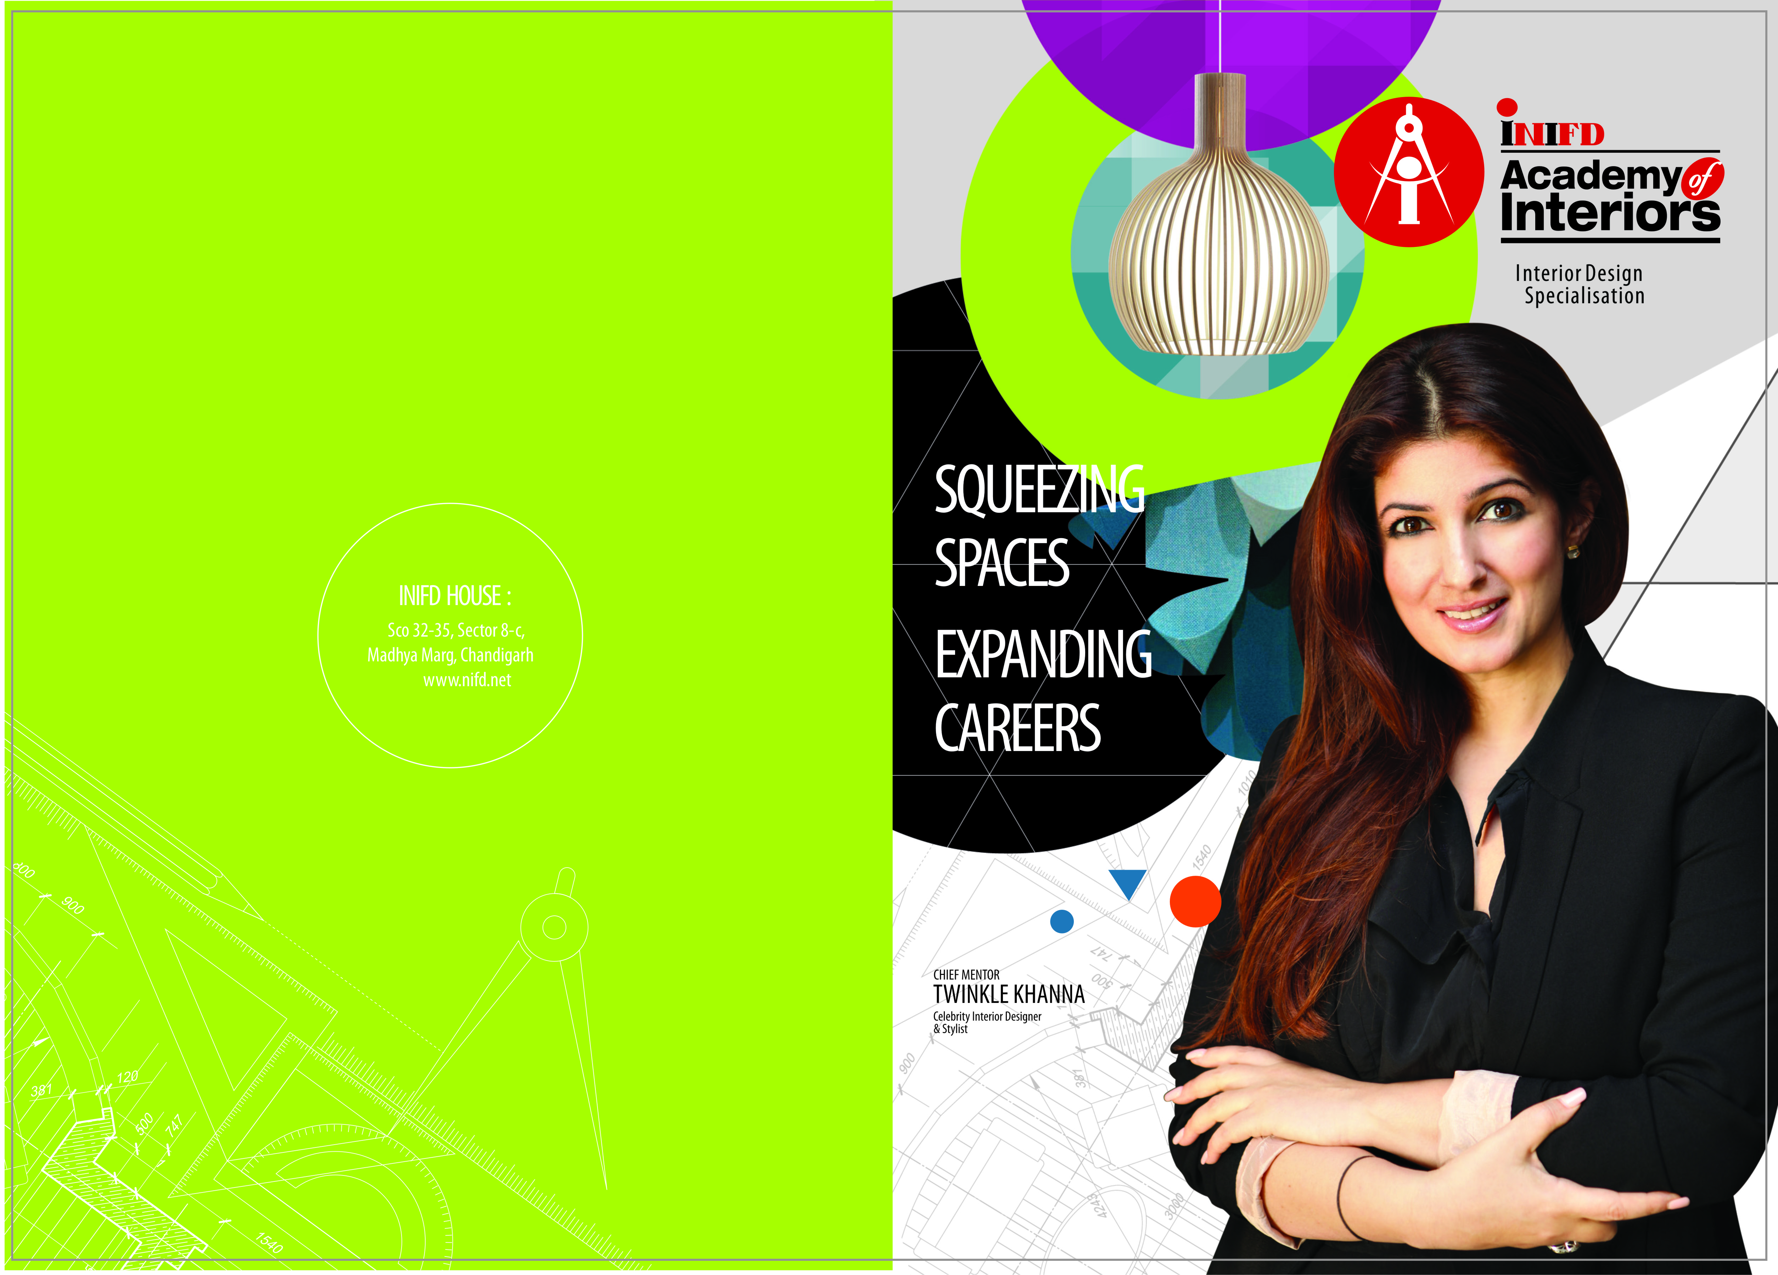

I

NIFD has launched “Academy of Interiors” with Chief Mentor Twinkle Khanna. The first of its kind exclusive Interior Design nationwide chain ‘INIFD Academy of Interiors’ has been started at 50 centres of which INIFD Kondhwa is one. It has been started specially to train students for the fastest growing Interior Design industry.
INIFD Celebrity Mentor Twinkle Khanna – is a Bollywood Star. She is the most high-end Interior Designer in India and owns a chain ‘The White Window’. She along with other mentors will be sharing their expertise with all the students of INIFD.
After legacy of 20 successful years in the field of design training with the launch of ‘INIFD Academy of Interiors’, now the students would get specialized training with practical industry experience making them experts in the Interior Designing field.”

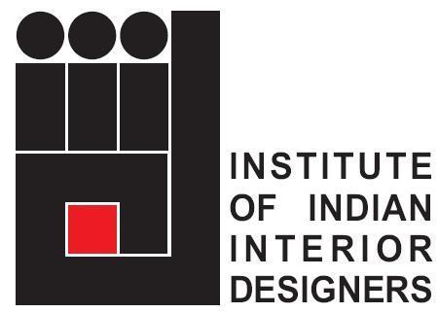
INIFD has made an exclusive tie-up IIID. Our students become members of IIID which is a prestigious opportunity.
Institute of Indian Interior Designers was founded with an aim to establish good professional & trade practices and ethics amongst its members and to highlight and enhance the image of the Interior Design Profession and exchange know‐how with similar organizations within the country & abroad. With over 8,000 members in 28 chapters & centers across India, IIID is a fraternity of the Interior Designers within the country as well as globally.
Knowledge Partners: DURAVIT
Duravit is our valued partner for conducting factory visits, workshops and professional training for our students of Interior Design
INIFD is proud to have produced over one 5 Lakh student Designers and more than twenty five thousand students have recently recruited by top international brands like Tommy Hilfiger, United colors of Benetton, Wills Lifestyle, Esprit, Pantaloons, Louis Philippe, Van Heusen, J.J.Valaya House, Raymond’s, Godrej, Durian & Sleek Furniture to name a few.

IMG Reliance: INIFD Classroom
From classroom to the industry: ONLINE PROGRAMS on style & strategy, ideas, celebrity endorsements, leadership, business & media – curated smart talks for students of Fashion & Interior Design
Showcasing a Specially Curated Knowledge Series with a talk show followed by Design Presentation by budding INIFD Fashion Designers and Interior Designers for the selection for direct entry to showcase and present their talent at Lakme Fashion Week.
These selected Fashion Design students will get an exclusive opportunity to showcase at INIFD LAUNCHPAD during LAKME FASHION WEEK and the selected Interior Design students get a chance to Design Sets of 5 Designer Shows at LAKME FASHION WEEK.

Official Knowledge Partners: Lakme Fashion Week.

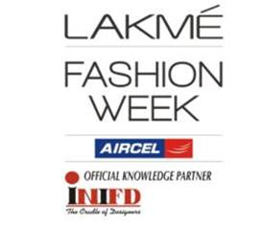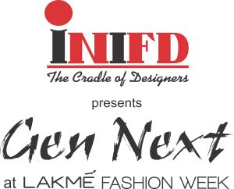
- INIFD is the only institute in the world which is tied up with Lakme FahionWeek. Students get a chance to walk the ramp with top designers like Neeta Lulla, JJ Walaya, James Farrerah & many more. Also get a chance to show case their collection in the GEN NEXT SHOW at Lakme Fashion Week India.
INIFD is the 'Official Education Partner” to Femina Miss India.

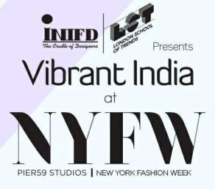
INIFD is also proud to be associated with London Fashion Week & New York Fashion Week. Students get to participate at an International level with the top tier designers of the world.

We are proud to have renowned designer Manish Malhotra as the Celebrity Mentor for Fashion Design. Students get online classes from Manish Malhotra which gives them an insight into the working of the Industry.
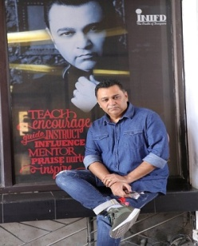
Ashley Rebello, Famous Bollywood Fashion Stylist, as a mentor will assist INIFD in designing quality syllabus and would be visiting INIFD to conduct various design workshops.

For Any Further Details Contact
INIFD Kondhwa Campus
Narayan Towers, Salunke Vihar Road,
Near Kotak Mahindra Bank,
Behind Salunke Vihar telephone exchange,
Next to Bliss Bakery & café
Kondhwa Pune. 411048

Contact No. 02026855544
Mob: 9822282817

Email us at: info@inifdkondhwa.com
Web: www.inifdkondhwa.com

